**PREDICTION OF RELEVANT DISEASES AMONG THE PEOPLE USING MACHINE LEARNNG MODELS**

**OBJECTIVE:**

The objective of this project is about predicting relevant diseases for a person using the powerful techniques from machine learning. Our application will helps for the making early predictions or diagnosing the diseases namely Alzheimer, Anemia, Diabetes and Chronic Kidney Disease with the help of ML algorithms.

**ABSTRACT:**

Computer-aided illness diagnosis is less expensive, saves time, is more accurate, and removes the need for additional personnel in medical decision making. Many nutrition surveys indicate that about a quarter of the world's population are suffering with some chronic diseases like anemia and diabetes. As a result, there is a pressing need to create an effective machine learning regressor capable of properly detecting anaemia and diabetes. The goal is to find out which individual classifier or group of classifier combinations obtain the highest accuracy in Red blood cell categorization for anaemia detection. Blood Glucose level is the concentration of glucose present in the blood of humans. Diabetes is a chronic illness characterized by the absence of glucose. Insulin therapy is needed to maintain Blood Glucose levels in the advised target range. According to global report on diabetes by World Health Organization, over 400 million people suffer from diabetes. Regular monitoring of Blood Glucose Level is of paramount importance in the treatment process. Diabetes can be found out in many ways. We use Machine Learning algorithms to predict whether the patient has diabetes or not. We used Lasso and Ridge regressions to detect and estimate the anemia. However the classifier Ridge performs better achieves an accuracy higher than the Lasso regression. Hence to achieve maximum accuracy in medical decision making, a better and powerful algorithm should be used. The outcomes of this algorithms decides whether the patient is infected with anemia or not. The proposed version generates a better response to the inputs to confirm the disease. The algorithms like Logistic regression, Support vector machine, artificial neural networks and Deep learning neural network are used to predict the chances of diabetes of a patient. First we take some parameters of patient which include blood pressure, sex, diabetes pedigree function, BMI, age, Insulin, skin thickness etc. Then by giving these features input to the machine learning algorithms we can predict the blood glucose level of the patient. Alzheimer's disease is an irreversible, progressive brain disorder that slowly destroys memory and thinking skills and, eventually, the ability to carry out the simplest tasks. Machine learning (ML), a branch of artificial intelligence, employs a variety of probabilistic and optimization techniques that permits PCs to gain from vast and complex datasets.

**KEYWORDS:** Diabetes, Lasso and Ridge regressions, Anemia, Logistic regression, Alzheimer's

**EXISTING SYSTEM:**

Traditional way of prediction basically uses historical observations to estimate the disease manually. Traditional forecasting practices won’t result a good accuracy because the work is entirely performed by humans. Machine Learning have different types of algorithms and each has its own structure of working procedure which contains different intuitions. In these intuitions, models are working on different procedures in different ways and also delivers high and less accuracies. This creates a lot of constraints regarding cases. The major challenge is to create a model for them so that no one have less accuracy. In this existing system we used Naïve Bayes to detect the diseases Anemia, Diabetes, Alzheimer’s and chronic kidney disease which results less accuracy.

**DISADVANTAGES:**

* Low efficiency.
* Time consuming.
* High complexities.
* Resources consuming

**PROPOSED SYSTEM:**

We propose a method that can be considered a useful system since it helps to reduce the limitations from traditional or existing methods. By providing support through the powerful algorithms other than naïve bayes, they can be able to generate best results for attributes without any overlap. This project has ability to make better predictions. This project is developed in a Python environment. The models involved in this application is Lasso and Ridge regressions, RF, Logistic regression, KNN, SVM, ANN

Flow of the project:

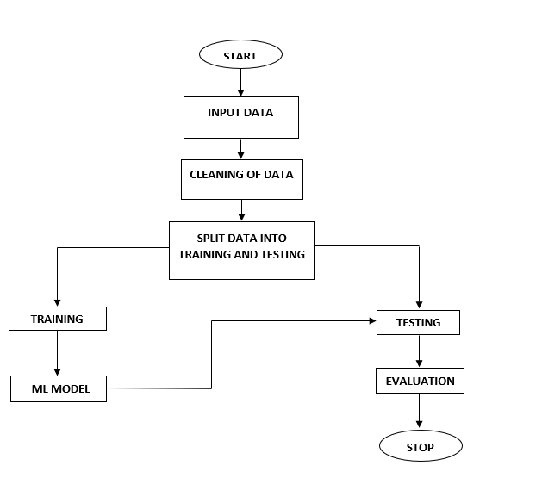

**ADVANTAGES:**

* High efficiency.
* Time Saving.
* Inexpensive.
* Low complexities.

**SYSTEM SPECIFICATIONS:**

# H/W SPECIFICATIONS:

# Processor - I3/Intel Processor

# RAM - 8GB (min)

* Hard Disk - 128 GB
* Key Board - Standard Windows Keyboard
* Mouse - Two or Three Button Mouse
* Monitor - Any

**S/W SPECIFICATIONS:**

* Operating System : Windows 10
* Server-side Script : Python 3.6
* IDE : PyCharm
* Libraries Used : Pandas, NumPy, Scikit-Learn, Keras
* Frame Work : Flask
* Data Base : MySql

**LEARNING OUTCOMES:**

* About Python.
* About PyCharm.
* About Pandas.
* About Numpy.
* About HTML.
* About CSS.
* About JavaScript.
* About Database.
* About Deep Learning.
* About Machine Learning
* About Artificial Intelligent.
* About how to use the libraries.
* Cloud Overview.
* Terminology of cloud.
* Virtualization.
* About how to create the registration table in sql.
* About future prediction outcomes.
* About how to generate the predictions with python code.
* Project Development Skills**:**
  + Problem analyzing skills.
  + Problem solving skills.
  + Creativity and imaginary skills.
  + Programming skills.
  + Deployment.
  + Testing skills.
  + Debugging skills.
  + Project presentation skills.
  + Thesis writing skills.